*LAB # 03*

CONSOLE INPUT AND OUTPUT

# *OBJECTIVE:*

*Taking input from user and controlling output position.*

Class tasks

**Tasks #01**

* **Code:**

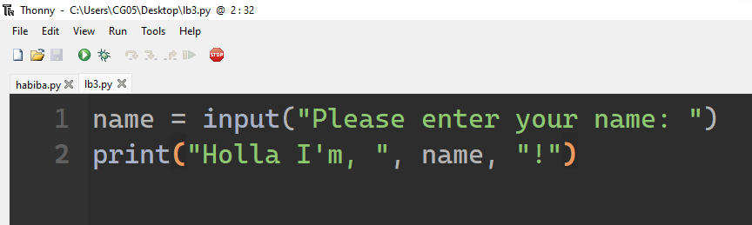

* **Output**

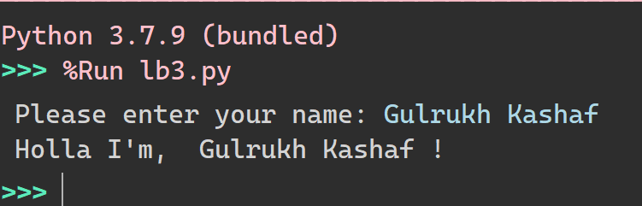

**Tasks #02**

* **Code:**

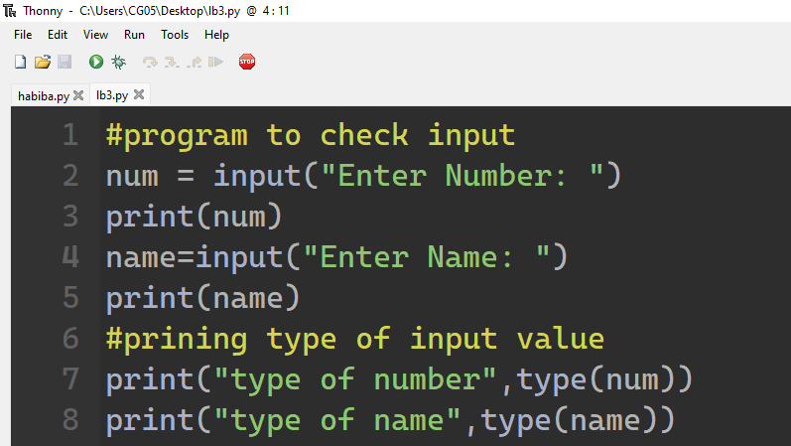

* **Output:**

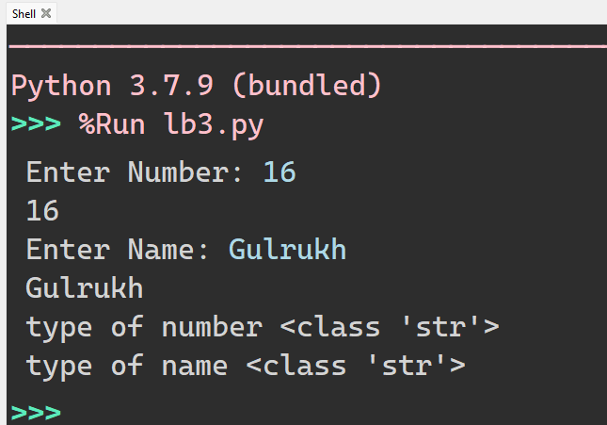

**Tasks #03 (T typecasting the input to Integer/Float)**

* **Code: (Sum)**

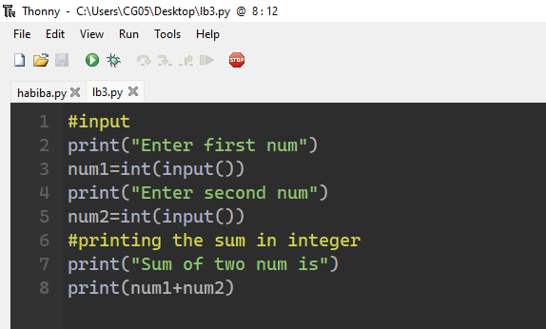

* **Output:**

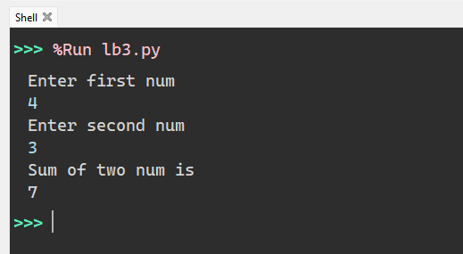

**(Subtraction)**

* **Code:**

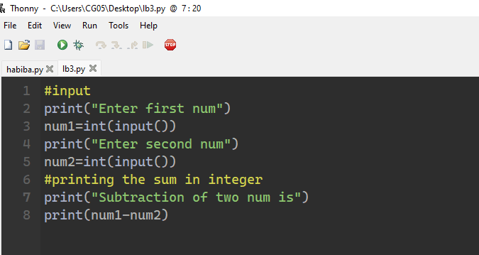

* **Output:**

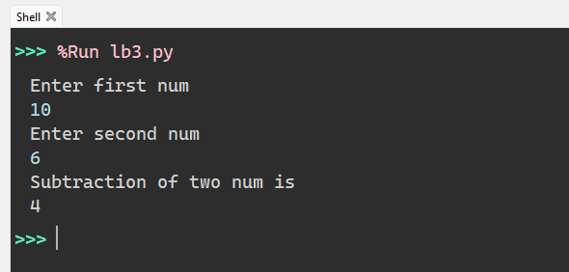

**(Multiplication)**

* **Code:**

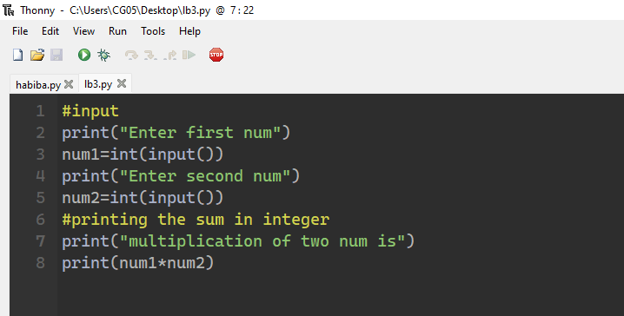

* **Output:**

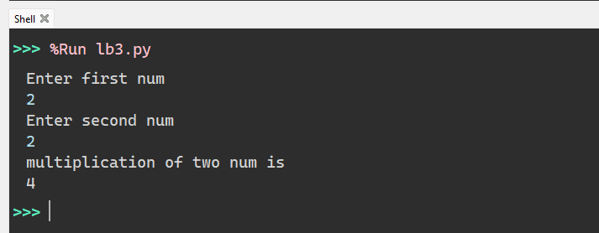

**(Division)**

* **Code:**

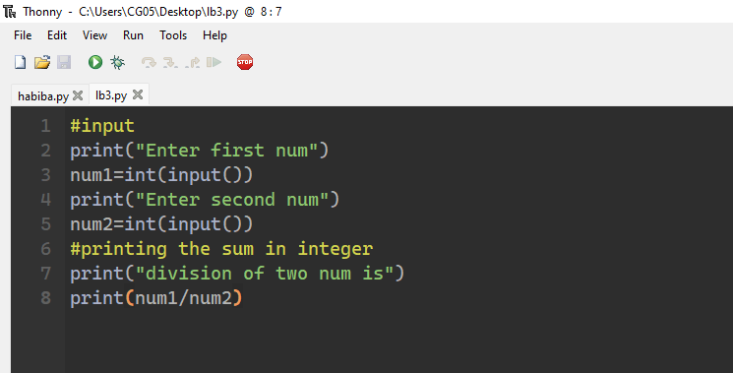

* **Output:**

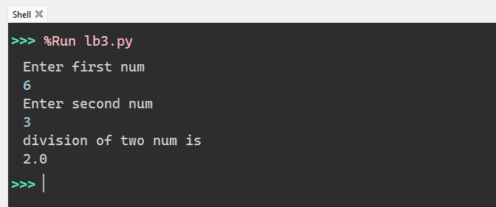

HOME tasks

***EXERCISE***

1. *Point out the errors or undefined/missing syntax, if any, in the following python programs.*

**Tasks #01A**

* **Code:**

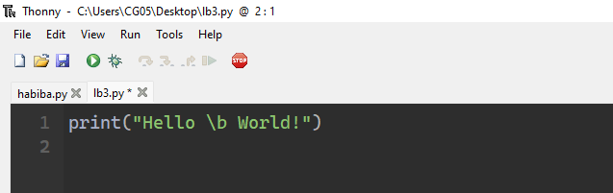

* **Output:**

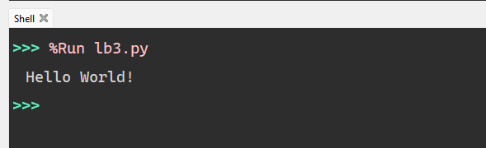

**Tasks #02A**

**Code (wrong one)**

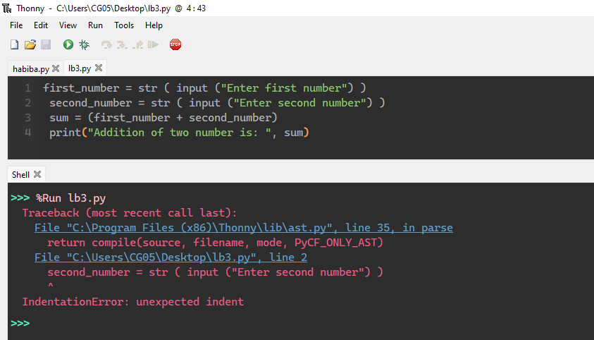

* **Code:(right one)**

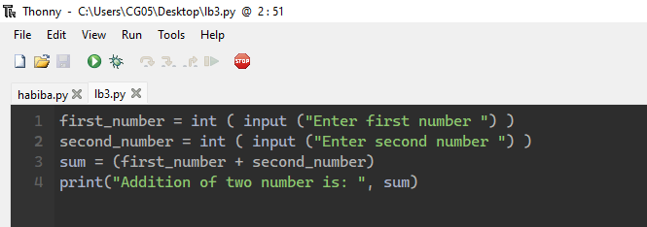

* **Output:**

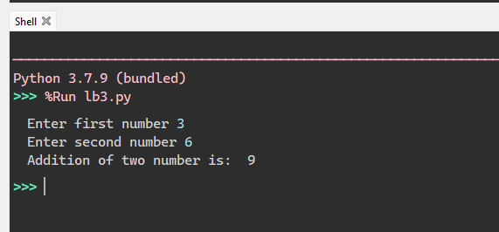

**Tasks #03A**

* **Code (wrong one)**

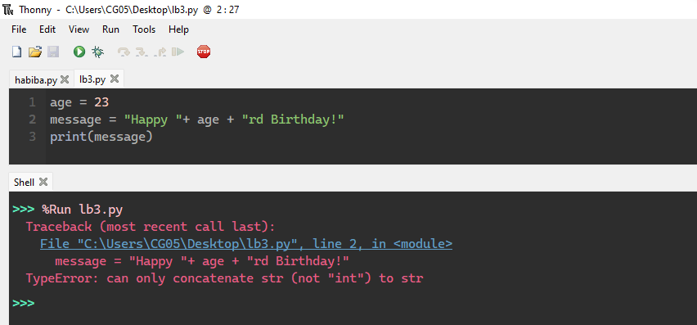

* **Code :(right one)**

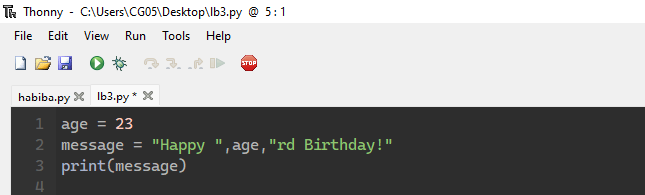

* **Output:**

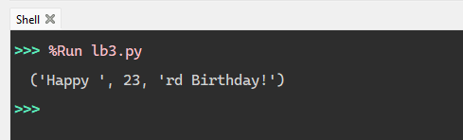

***Exercise B :What would be the output of the following programs:***

**Tasks #01B**

* **Code:**

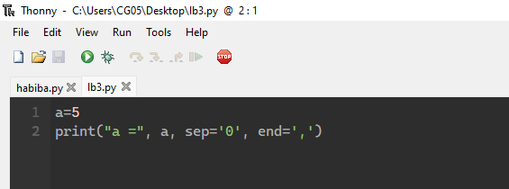

* **Output:**

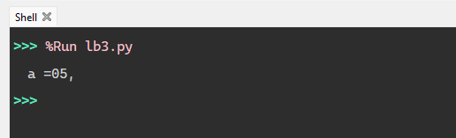

**Tasks #02B**

**Code:**

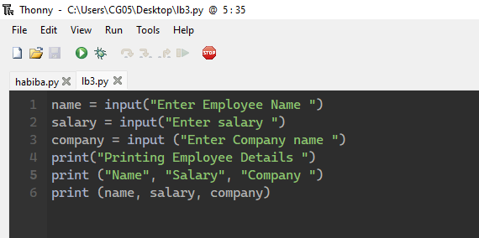

* **Output:**

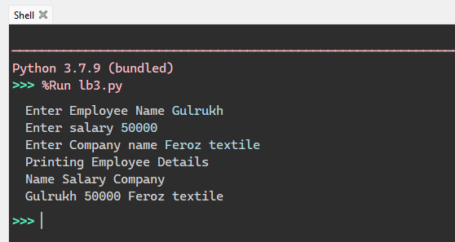

**Tasks #03B**

* **Code:**

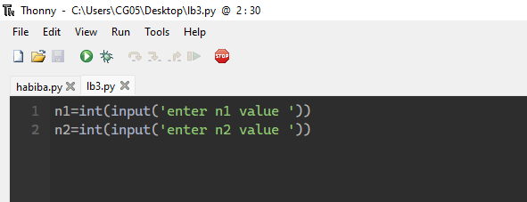

* **Output:**

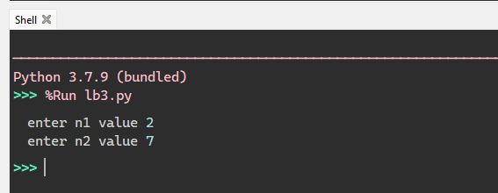

***EXERCISE C: Write Python programs for the following:***

**Tasks #01C**

* **Code:**

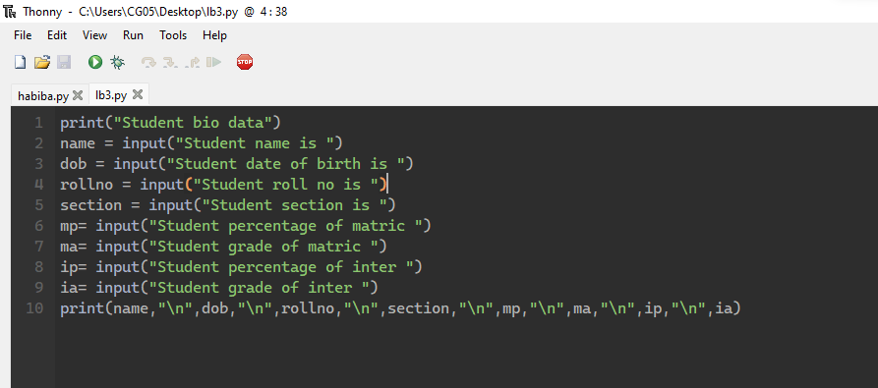

* **Output:**

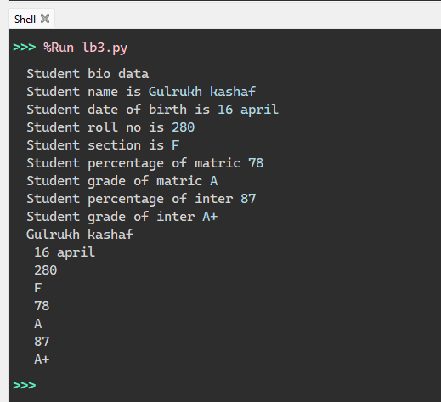

**Tasks #02C**

* **Code:**

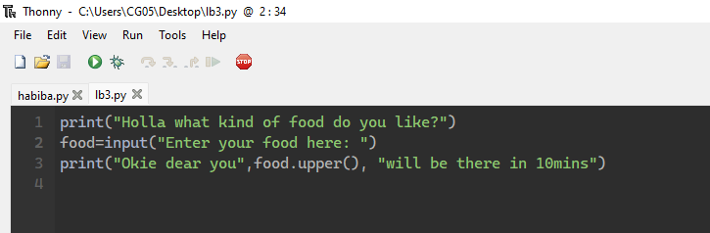

* **Output:**

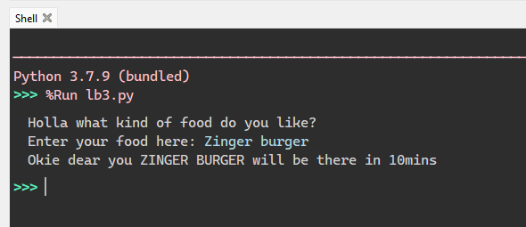

**Tasks #03C**

* **Code:**

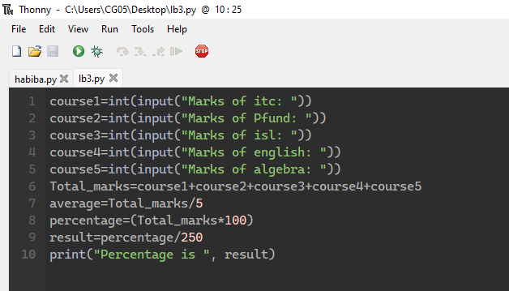

* **Output:**

